## Instructions for Accessing the AWS Server

**Step 1:**

Open PuTTygen (Should already be installed if you have putty installed).

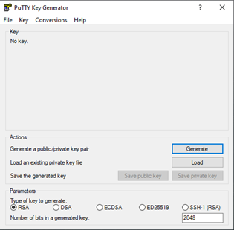

**Step 2:**

Click “Load” and select the LitterDetection.pem file provided by Jason.

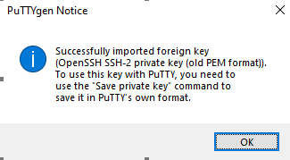

You will now have created the Putty Private Key ( .PPK ) file.

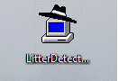

**Step 3:**

Open PuTTy and paste “ec2-44-232-96-196.us-west-2.compute.amazonaws.com” under hostname.

**Step 4:**

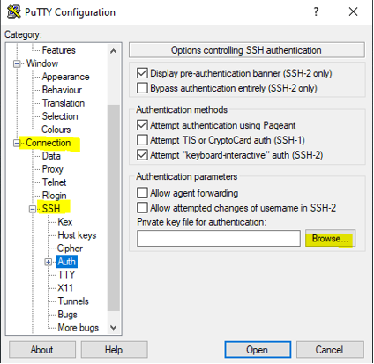

Select the dropdowns **Connection/SSH/** and then click on **Auth**.

Here, you will select “Browse…” and then select the previously created “.ppk” file.

**Step 5:**

Necessary for interfacing with jupyter-notebook. Goto **Connection/SSH/Auth/Tunnels** and enter the information below. Then, press “Add”. (Remember to save your ubuntu session after adding tunneling)

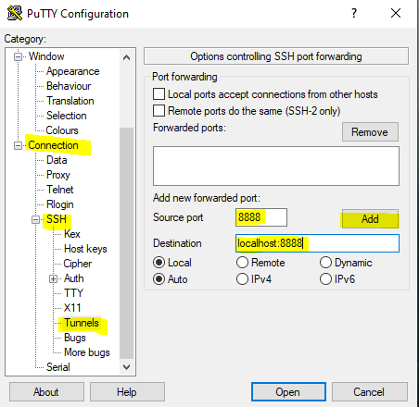

**Step 6:**

Now login with username “ubuntu”.